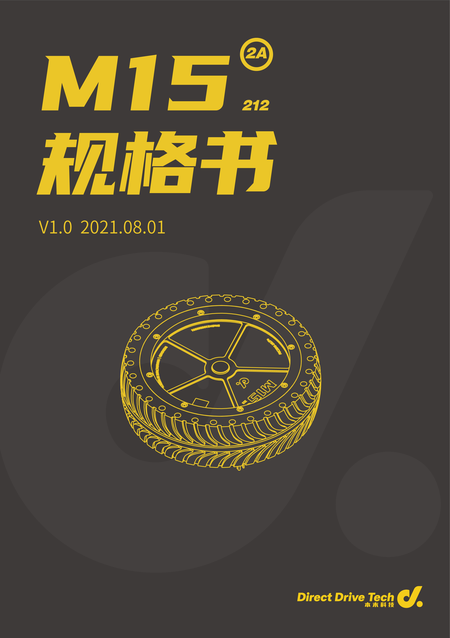
Contents
）

Disclaimer 3
Safety Precautions 3
Product Introduction 4
Product Features 4
Products List 5
Moter Driver Interface and Cable Instruction 6
Installation Guidelines 7
M1502A_112 Moter Driver Instructions 8
CAN Communication Protocol 10
Firmware Update 16
Motor Parameter 17

- Disclaimer

Thank you for purchasing the M15 series permanent magnetic synchronous motor (hereinafter referred to as "motor") from Dongguan Direct Drive Technology Co., Ltd. (hereinafter referred to as Direct Drive Tech). This manual has been published to guide the use of this product.

Before starting operation, please be sure to read through this manual carefully and follow the relevant instructions to avoid injury or damage. By using this product, you are deemed to have accepted all the terms and contents of the specification and all relevant documents of this product. You promise to use this product only for legitimate purposes and take full responsibility for the possible consequences of using this product. Direct Drive Tech shall not be responsible for any damage, injury, or legal liability caused by the direct or indirect use of this product.

This product and its specification are copyrighted by Direct Drive Tech Co., Ltd. It is not allowed to reproduce in any form without permission.

Direct Drive Tech Co., Ltd. reserves the right for the modification and final interpretation of this product and all documents of its specification, and Direct Drive Tech may modify the information of this specification without prior notice when it obtains new information, knowledge, or experience.

- Safety Precautions

- Before starting operation, make sure whether the working voltage is the one specified in this manual.
- Make sure the motor is used within the specified ambient temperature range.
- Avoid soaking the motor in water. Failure to do this may result in abnormal operation or damage to the motor.
- Before starting operation, be sure to correctly and securely perform the cable to avoid loose contact.
- Before starting operation, refer to the installation guidelines to make sure the motor is installed correctly and securely.
- Before starting operation, refer to the installation guidelines to make sure the external output part of the motor is installed correctly and securely.
- During operation, avoid damaging the cables. Failure to do this may result in abnormal operation or damage to the motor.
- During operation, do not touch the rotating parts of the motor. This may result in injury.
- When the motor produces high torque output with heat generation, do not touch the motor. This may result in scald.
- Do not disassemble the motor without permission. This may result in abnormal operation or damage to the motor and bring protentional safety hazards.

- Introduction

M15 series motor is an independently developed product by Direct Drive Technology Co., Ltd. This product is a highly reliable permanent magnet synchronous motor, integrating external rotor BLDC motors, encoder, and servo system based on the concept of integration development. It has compact structure, ease of installation, stability in operation, small size and large torque, which is especially suitable for the following direct drive fields: robots, AGVs, automation equipment, warehousing logistics, etc. By optimizing the number of poles and wedges, wedge shape, air gap, permanent magnet materials, etc., the motor can ensure larger torque output, less torque fluctuations, and provides high-performance direct drive application solutions. The motor driver embeds the field-oriented control (FOC) algorithm. Together with the high-precision sensor, the motor achieves great control accuracy and nice mute effect. The drive has a complete and reliable motor OBD monitoring and protection mechanism to ensure the safe and reliable operation of the motor.
- Product Features

1. Integrated design of motor and motor driver.
2. Small size and high torque, ultra-low velocity supported.
3. CAN communication mode supported.
4. Special design in structure allows the sensor to measure the overall temperature of motor.
5. Angle, velocity, current, fault value and other information of the motor can be obtained through communication.
6. Equipped with complete monitoring mechanism and protection.
7. High Ingress Protection Rating.

- Product List

- 1. Motor Assembly

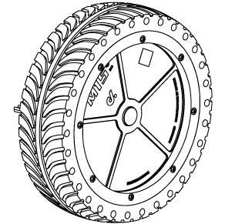

- Motor Driver Interface and Cable Instructions

Cable Diagram：

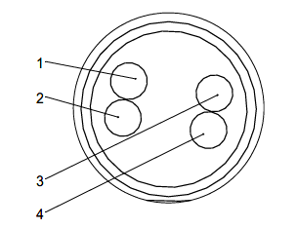

Index | Name | Instruction
1 | Power Positive (Red) | Rated Voltage 24V
2 | Power Negative (Blue) | GND
3 | CAN Bus High (Yellow) | This interface is a non-isolated CAN interface. When connecting, please make sure the motor driver and the bus are connected correctly
4 | CAN Bus Low (Green）

- Installation Guidelines

Please refer to the size and position of the motor mounting holes to install the motor on the custom device.

1. Motor installation interface
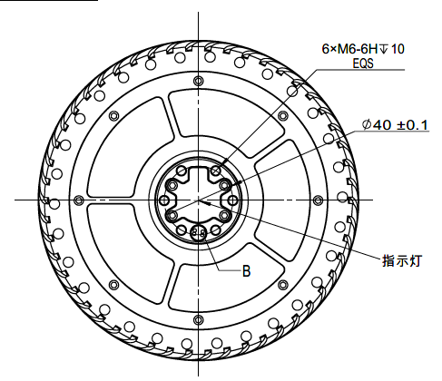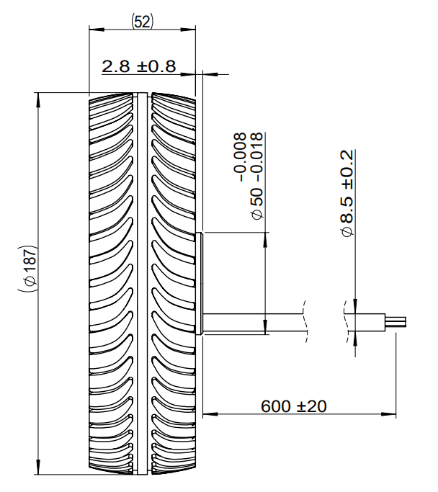
Bottom View Side View

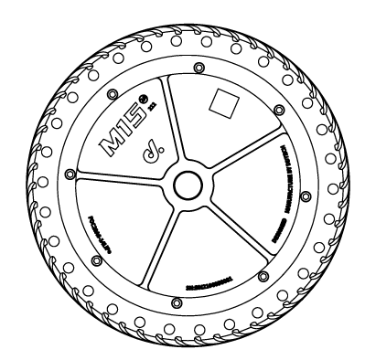
Vertical View

2. Cautions
2.1 It is recommended that the indicator light is unobstructed.
2.2 Avoid pulling the cable.
2.3 Carefully select the screws with proper length and shape to avoid unreliable installation.

- M1502A_112 Motor Driver Instructions

The driver is able to perform close-loop control of the motor’s angle, velocity or current according to the user’s target instructions, and feeds back the motor’s real time angle, velocity, current, temperature and other information, through the CAN bus.
Description of CAN ID Indicator Light：
ID | Description of Indicator Light
1 | Green light flashes once every 5s
2 | Green light flashes twice every 5s
3 | Green light flashes 3 times every 5s
4 | Green light flashes 4 times every 5s
5 | Green light flashes 5 times every 5s
6 | Green light flashes 6 times every 5s
7 | Green light flashes 7 times every 5s

Descriptions of Fault Indicator Light, Buzzer and Related Protection Regulations:
Fault Description | Description of Fault Indicator Light and Buzzer
Under voltage1（voltage is higher than 18V and lower than 22V） | The red light is always on
Under voltage2（voltage is lower than18V） | The buzzer keeps beeping, and the motor shuts down
Over voltage（voltage is higher than 63V） | The buzzer keeps beeping, and the motor shuts down
Over current（greater than 15A） | The buzzer keeps beeping, and the motor shuts down
Over velocity（Greater than the maximum velocity of the motor） | The red light is always on
Over heat 1（temperature of motor winding>80℃） | The yellow light flashes every 2s to corresponding ID
Over heat 2（temperature of motor winding >120℃） | The yellow light is always on, and the motor powers down
Angle sensor failure | The red light is always on, and the motor shuts down
Abnormal signal of angle sensor | The red light flashes to corresponding ID
Cannot access the motor | Long beep followed by short beep from the buzzer, and the motor shuts down
Phase loss | Three short beeps from buzzer, and the motor shuts down

The correspondence between CAN communication identifiers is as follows:
Motor ID | 1 | 2 | 3 | 4 | 5 | 6 | 7 | 8
Feedback Identifier | 0x97 | 0x98 | 0x99 | 0x9A | 0x9B | 0x9C | 0x9D | 0x9E
Control Identifier | 0x32 |  |  |  | 0x33

- CAN Communication Protocol

Rate: 500kbps
Frame type: Standard frame
Data length: 8 bytes
Open-loop mode: The set value -32767 ~ 0 ~ -32767 corresponds from the reverse maximum velocity to the maximum velocity
Current loop mode: The set value is - 32767 ~ 32767 corresponds to -33A ~ 33A
Velocity loop mode: The set value is -210 ~ 210 corresponds to -210 ~ 210rpm
Angle loop mode: 0 ~ 32767 corresponds to 0º ~ 360º
Data feedback method includes active reporting and polling.
Motor identifier range: 0x32 ~ 0x500

Operation steps:
- Set the feedback method (polling method or active reporting method, default in active reporting method at 1kHz)
- Set motor mode (open loop, current loop, velocity loop, angle loop, default in open loop)
- Send the set value.

1. Command in open-loop mode (format of other modes is the same):
Open-loop command, range: -32767 ~ 32767.
Command
Identifier | 0x32
Data field | DATA  [0] | DATA  [1] | DATA  [2] | DATA  [3] | DATA  [4] | DATA  [5] | DATA  [6] | DATA  [7]
Descrip-tion | Open loop set high 8 bits | Open loop set low 8 bits | Open loop set high 8 bits | Open loop set low 8 bits | Open loop set high 8 bits | Open loop set low 8 bits | Open loop set high 8 bits | Open loop set low 8 bits
Motor ID | 1 |  | 2 |  | 3 |  | 4

Command
Identifier | 0x33
Data field | DATA  [0] | DATA  [1] | DATA  [2] | DATA  [3] | DATA  [4] | DATA  [5] | DATA  [6] | DATA  [7]
Description | Open loop set high 8 bits | Open loop set low 8 bits | Open loop set high 8 bits | Open loop set low 8 bits | Open loop set high 8 bits | Open loop set low 8 bits | Open loop set high 8 bits | Open loop set low 8 bits
Motor ID | 5 |  | 6 |  | 7 |  | 8

Feedback value
Feedback, at frequency 1KHZ
Identif-ier | 0x96+Motor ID
Data field | DATA  [0] | DATA  [1] | DATA  [2] | DATA  [3] | DATA  [4] | DATA  [5] | DATA  [6] | DATA  [7]
Descri-ption | Velocity measurement set high 8 bits | Velocity measurement set low 8 bits | current value set high 8 bits | Torque current value set low 8 bits | Angle value set high 8 bits | Angle value set low 8 bits | Fault value | Motor mode
Velocity range: -210 ~ 210RPM
Current range: -32767~32767，corresponds to -33A~33A
Angle value range 0 ~ 32767 corresponds to 0~360°。

Fault value and corresponding fault description:
Fault value | Fault description
0x00 | No fault
0x01 | Undervoltage 1 (voltage higher than 18V and lower than 22V)
0x02 | Undervoltage 2 (voltage below 18V)
0x03 | Over-voltage (voltage higher than 63v)
0x0A | Over-current (greater than 15a)
0x14 | Over velocity (greater than the maximum velocity of motor)
0x1E | Over-temperature 1 (motor winding temperature > 80 ℃)
0x1F | Over-temperature 2 (greater than 120 ℃)
0x2A | Angle sensor failure
0x2B | Abnormal angle sensor signal
0x3C | Unable to access the motor
0x51 | Phase loss of three-phase line

2、Example of setting the sending mode and feedback mode
Set mode
Identifier | 0x105
Data field | DATA  [0] | DATA  [1] | DATA  [2] | DATA  [3] | DATA  [4] | DATA  [5] | DATA  [6] | DATA  [7]
Description | Mode value | Mode value | Mode value | Mode value | Mode value | Mode value | Mode value | Mode value
Motor ID | 1 | 2 | 3 | 4 | 5 | 6 | 7 | 8
Feedback content
Identifier | 0x200+Motor ID
Data field | DATA  [0] | DATA  [1] | DATA  [2] | DATA  [3] | DATA  [4] | DATA  [5] | DATA  [6] | DATA  [7]
Description | Mode value | 0xFF | 0xFF | 0xFF | 0xFF | 0xFF | 0xFF | 0xFF

Mode value： | Description
0X00 | Voltage open loop
0x01 | Set to current loop
0x02 | Set to velocity loop
0x03 | Set to angle loop
0x09 | Disabled motor
0x0A | Enable motor (default enable)

Set feedback method
Identifier | 0x106
Data field | DATA  [0] | DATA  [1] | DATA  [2] | DATA  [3] | DATA  [4] | DATA  [5] | DATA  [6] | DATA  [7]
Description | method | method | method | method | method | method | method | method
Motor ID | 1 | 2 | 3 | 4 | 5 | 6 | 7 | 8
Feedback content
Identifier | 0x264+ Motor ID
Data field | DATA  [0] | DATA  [1] | DATA  [2] | DATA  [3] | DATA  [4] | DATA  [5] | DATA  [6] | DATA  [7]
Description | method | 0xFF | 0xFF | 0xFF | 0xFF | 0xFF | 0xFF | 0xFF

Method: The highest bit of the 8-bit data is set as the active reporting or polling (1: polling, 0: active reporting). The lower 7 bits are the reporting frequency under the active reporting method, range: 1 ~ 127ms.
E.g. Data 0b1000 0000 -- indicates that the polling method is set.
Data 0b0100 0000 - indicates that the data is reported once in 64ms, in active reporting method.
Note:
Under the polling mode, the setting of reporting frequency is invalid.
If the feedback mode is not set, it is the active reporting method for every 1ms, by default.
3、Operations in polling method
Command
Identif-ier | 0x107
Data field | DATA  [0] | DATA  [1] | DATA  [2] | DATA  [3] | DATA  [4] | DATA  [5] | DATA  [6] | DATA  [7]
Description | Motor ID | Target content 1 | Target content 2 | Target content 3 | Custom  -ized value | Reserved | Reserved | Reserved
Feedback content
Identif-ier | 0x96+Motor ID
Data field | DATA  [0] | DATA  [1] | DATA  [2] | DATA  [3] | DATA  [4] | DATA  [5] | DATA  [6] | DATA  [7]
Descri-ption | Target content 1  high 8 bits | Target content 1  low 8 bits | Target content 2  high 8 bits | Target content 2  low 8 bits | Target content 3  high 8 bits | Target content 3  low 8 bits | Custom  -ized  value | Reserved

Target content value：
0x01: Velocity
0x02: Current
0x03: Temperature
0x04: Angle
0x05: Fault value
0x06: Control mode
Customized value: Any values ranging from 0 to 255. The value can be used to distinguish the feedback frames.
Reserved: Any value
E.g. The motor receives the following frame：
Identifier 0x107
Data field | DATA  [0] | DATA  [1] | DATA  [2] | DATA  [3] | DATA  [4] | DATA  [5] | DATA  [6] | DATA  [7]
Description | 0x01 | 0x01 | 0x03 | 0x04 | 0xAA | Reserved | Reserved | Reserved

Feedback content as：
Identifier 0x97
Data field | DATA  [0] | DATA  [1] | DATA  [2] | DATA  [3] | DATA  [4] | DATA  [5] | DATA  [6] | DATA  [7]
Description | Velocity high 8 bits | Velocity low 8 bits | Temper-ature high 8 bits | Temper-ature low 8 bits | Angle high 8 bits | Angle low 8 bits | 0xAA | Reserved

4、Motor ID setting：
Command
Identifier | 0x108
Data field | DATA  [0] | DATA  [1] | DATA  [2] | DATA  [3] | DATA  [4] | DATA  [5] | DATA  [6] | DATA  [7]
Descri-ption | Motor ID | Reserved | Reserved | Reserved | Reserved | Reserved | Reserved | Reserved
Feedback content
Identifier | 0x96+Motor ID
Data domain | DATA  [0] | DATA  [1] | DATA  [2] | DATA  [3] | DATA  [4] | DATA  [5] | DATA  [6] | DATA  [7]
Descri-ption | Motor ID | 0xFF | 0xFF | 0xFF | 0xFF | 0xFF | 0xFF | 0xFF
Note: Only one motor ID can be set for each power on, and whether the setting is successful can be judged by the feedback identifier.
5、CAN terminal resistor setting：
Identifier：0x109
Data field | DATA  [0] | DATA  [1] | DATA  [2] | DATA  [3] | DATA  [4] | DATA  [5] | DATA  [6] | DATA  [7]
Description | 0/1 | 0/1 | 0/1 | 0/1 | 0/1 | 0/1 | 0/1 | 0/1
Motor ID | 1 | 2 | 3 | 4 | 5 | 6 | 7 | 8
0: Disconnect the terminal resistor
1: Connect the terminal resistor
The terminal resistor is disconnected by default.
- Firmware Update

Special software tool can be used for updating. If required, please contact the official after-sales service.

- Motor parameters

Motor parameters with M15 built-in driver
Unload velocity | 210rpm±10rpm
Unload current | ≤0.25A
Rated velocity | 115rpm
Rated torque | 9.6Nm
Rated current | 12A
Maximum efficiency | ≥76%
Stall torque | 17Nm
Stall current | ≤15.5A
Rated voltage | 24VDC
Torque constant | 0.8Nm/A（在额定转速下测得）
Velocity constant | 8.7rpm/V
Ambient temperature | -20℃~45℃
Motor weight | 2.3kg
Encoder resolution | 16384
Absolute accuracy | 8192
Ingress protection rating | IP55
Noise level  Note: the above parameters are measured under 24VDC | ≤52dB

